**OOP LAB 2**

**RAAHIM**

**24k-0543**

**Task 1:**

#include <iostream>

using namespace std;

struct Book {

string title, author;

int year;

};

int main() {

int n, Nyear;

cout << "Enter number of books: ";

cin >> n;

Book* books = new Book[n];

for (int i = 0; i < n; i++) {

cout << "Enter title: ";

cin >> books[i].title;

cout << "Enter author: ";

cin >> books[i].author;

cout << "Enter year: ";

cin >> books[i].year;

}

cout << "Enter year to filter books: ";

cin >> Nyear;

cout << "Books published after " << Nyear << ":\n";

for (int i = 0; i < n; i++) {

if (books[i].year > Nyear)

cout << books[i].title << " by " << books[i].author<< " in " << books[i].year << "\n";

}

delete[] books;

return 0;

}

**OUTPUT:**  
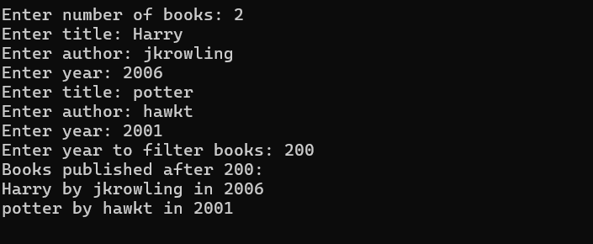

**Task 2:**

#include <iostream>

using namespace std;

int main(){

int row1,col1,row2,col2;

cout<<"Enter num of rows for matrix 1: ";

cin>>row1;

cout<<"Enter num of columns for matrix 1: ";

cin>>col1;

cout<<"Enter num of rows for matrix 2: ";

cin>>row2;

cout<<"Enter num of columns for matrix 2: ";

cin>>col2;

int** m1=new int*[row1];

for (int i=0;i<row1;i++){

m1[i]=new int[col1];

}

int** m2=new int*[row2];

for (int i=0;i<row2;i++){

m2[i]=new int[col2];

}

cout << "Enter the elements of matrix 1:" << endl;

for (int i=0;i<row1;i++){

for (int j=0;j<col1;j++){

cout<<"enter element ["<<i<<"]["<<j<<"]: ";

cin>>m1[i][j];

}

}

cout << "Enter the elements of matrix 2:" << endl;

for (int i=0;i<row2;i++){

for (int j=0;j<col2;j++){

cout<<"enter element ["<<i<<"]["<<j<<"]: ";

cin>>m2[i][j];

}

}

if (row1==row2 && col1==col2){

int add[row1][col1];

for (int i=0;i<row1;i++){

for (int j=0;j<col1;j++){

add[i][j]=m1[i][j]+m2[i][j];

}

}

int sub[row1][col1];

for (int i=0;i<row1;i++){

for (int j=0;j<col1;j++){

sub[i][j]=m1[i][j]-m2[i][j];

}

}

cout<<"ADDITION:"<<endl<<endl;

for (int i=0;i<row1;i++){

for (int j=0;j<col1;j++){

cout<<add[i][j]<<" ";

}

cout<<endl;

}

cout<<"\nSUBTRACTION:"<<endl<<endl;

for (int i=0;i<row1;i++){

for (int j=0;j<col1;j++){

cout<<sub[i][j]<<" ";

}

cout<<endl;

}

} else {

cout<<"Operations not possible";

}

delete m1,m2;

}

**OUTPUT:**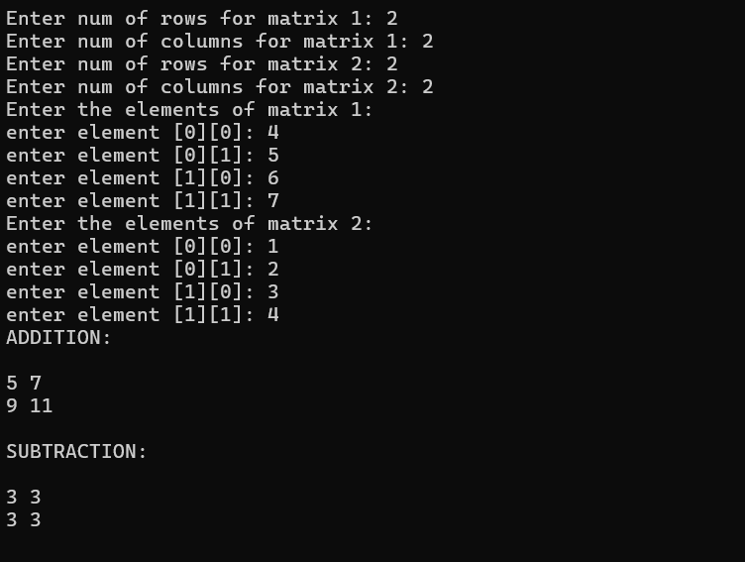

**TASK 3:**

#include <iostream>

#include <string>

using namespace std;

struct Employees{

string name;

int hoursWorked;

int hourlyRate;

};

int main(){

Employees employee;

int a;

cout<<"Enter num of Employees: ";

cin>>a;

Employees *emp=new Employees[a];

for (int i=0;i<a;i++){

cout<<"\nEnter details for Employee "<<i+1<<": "<<endl;

cout<<"Name: ";

cin>>emp[i].name;

cout<<endl<<"Hours Worked: ";

cin>>emp[i].hoursWorked;

cout<<endl<<"Hourly Rate: ";

cin>>emp[i].hourlyRate;

}

int Totalsale;

for (int i=0;i<a;i++){

Totalsale=emp[i].hourlyRate*emp[i].hoursWorked;

cout<<"Total salary of Employee "<<i+1<<": "<<Totalsale<<endl;

}

delete emp;

}

**OUTPUT:**

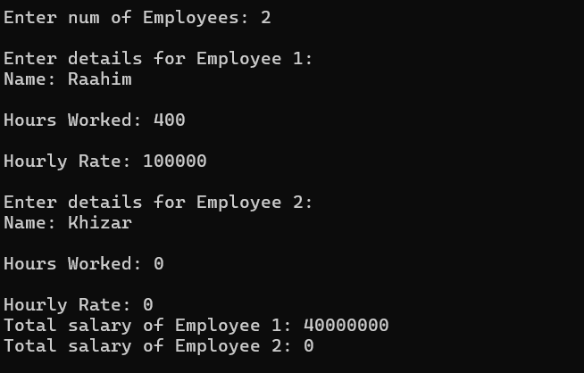

**TASK 4:**

#include <iostream>

#include <string>

using namespace std;

int main(){

int a;

cout<<"Enter number of strings: ";

cin>>a;

string *arr=new string[a];

for (int i=0;i<a;i++){

cout<<"Enter String "<<i+1<<": ";

cin>>arr[i];

}

cout<<"UNSORTED ARRAY: "<<endl;

for (int i=0;i<a;i++){

cout<<arr[i]<<endl;

}

for(int i=0;i<a-1;i++){

for (int j=0;j<a-i-1;j++){

if (arr[j]>arr[j+1]){

swap(arr[j],arr[j+1]);

}

}

}

cout<<"SORTED ARRAY: "<<endl;

for (int i=0;i<a;i++){

cout<<arr[i]<<endl;

}

delete arr;

}

**OUTPUT**:  
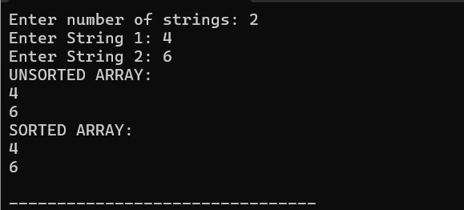

**TASK 5:**  
#include <iostream>

using namespace std;

int main() {

int size;

cout << "Enter the size of the array: ";

cin >> size;

int* arr = new int[size];

cout << "Enter " << size << " integers:\n";

for (int i = 0; i < size; ++i) {

cout << "Element " << i + 1 << ": ";

cin >> arr[i];

}

int* ptr = arr;

cout << "Array elements using pointer arithmetic:\n";

for (int i = 0; i < size; ++i) {

cout << *(ptr + i) << " ";

}

cout << "\n";

int sum = 0;

ptr = arr;

for (int i = 0; i < size; ++i) {

sum += *(ptr + i);

}

cout << "Sum of array elements: " << sum << "\n";

delete[] arr;

return 0;

}

**OUTPUT**:

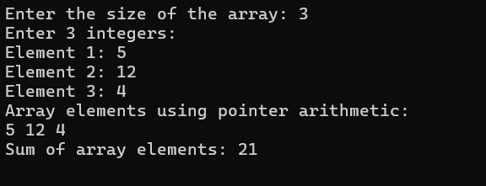

**TASK 6**:  
#include <iostream>

#include <string>

using namespace std;

struct Student {

string Name;

int RollNumber;

double marks[3];

};

double calculateAverage(const Student& student) {

double sum = 0;

for (int i = 0; i < 3; ++i) {

sum += student.marks[i];

}

return sum / 3;

}

int main() {

int numStudents;

cout << "Enter the Number of Students: ";

cin >> numStudents;

Student* students = new Student[numStudents];

for (int i = 0; i < numStudents; ++i) {

cout << "Enter details for student " << i + 1 << ":\n";

cout << "Name: ";

cin.ignore();

getline(cin, students[i].Name);

cout << "Roll Number: ";

cin >> students[i].RollNumber;

cout << "Marks in 3 subjects:\n";

for (int j = 0; j < 3; ++j) {

cout << "Subject " << j + 1 << ": ";

cin >> students[i].marks[j];

}

}

cout << "\nStudent Averages:\n";

for (int i = 0; i < numStudents; ++i) {

double average = calculateAverage(students[i]);

cout << "Student: " << students[i].Name << ", Roll Number: " << students[i].RollNumber

<< ", Average Marks: " << average << "\n";

}

delete[] students;

return 0;

}

**OUTPUT**:  
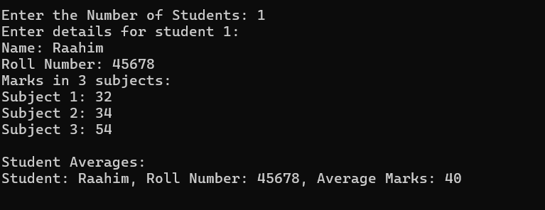

**TASK 7:**

#include <iostream>

using namespace std;

int main() {

int rowA, colA, rowB, colB;

cout << "Enter number of rows for matrix A: ";

cin >> rowA;

cout << "Enter number of cols for matrix A: ";

cin >> colA;

cout << "Enter number of rows for matrix B: ";

cin >> rowB;

cout << "Enter number of cols for matrix B: ";

cin >> colB;

if (colA != rowB) {

cout << "Matrix multiplication not possible!" << endl;

return 0;

}

int** matA = new int*[rowA];

int** matB = new int*[rowB];

int** result = new int*[rowA];

for (int i = 0; i < rowA; i++) matA[i] = new int[colA];

for (int i = 0; i < rowB; i++) matB[i] = new int[colB];

for (int i = 0; i < rowA; i++) result[i] = new int[colB]{};

cout << "Enter elements of Matrix A:" << endl;

for (int i = 0; i < rowA; i++) {

for (int j = 0; j < colA; j++) {

cout << "A[" << i << "][" << j << "]: ";

cin >> matA[i][j];

}

}

cout << "Enter elements of Matrix B:" << endl;

for (int i = 0; i < rowB; i++) {

for (int j = 0; j < colB; j++) {

cout << "B[" << i << "][" << j << "]: ";

cin >> matB[i][j];

}

}

for (int i = 0; i < rowA; i++) {

for (int j = 0; j < colB; j++) {

for (int k = 0; k < colA; k++) {

result[i][j] += matA[i][k] * matB[k][j];

}

}

}

cout << "Resultant Matrix:" << endl;

for (int i = 0; i < rowA; i++) {

for (int j = 0; j < colB; j++) {

cout << result[i][j] << " ";

}

cout << endl;

}

for (int i = 0; i < rowA; i++) delete[] matA[i];

for (int i = 0; i < rowB; i++) delete[] matB[i];

for (int i = 0; i < rowA; i++) delete[] result[i];

delete[] matA;

delete[] matB;

delete[] result;

return 0;

}

**OUTPUT**:

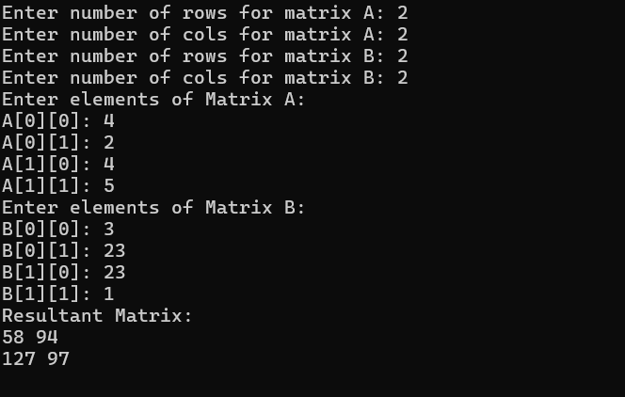

**TASK 8:**  
#include <iostream>

using namespace std;

int main() {

int size;

cout << "Enter the size of the array: ";

cin >> size;

int **arr = new int*[size];

for (int i = 0; i < size; i++) {

arr[i] = new int;

}

cout << "Enter values for the array:\n";

for (int i = 0; i < size; i++) {

cin >> *arr[i];

}

cout << "The array values are:\n";

for (int i = 0; i < size; i++) {

cout << *arr[i] << " ";

}

cout << endl;

for (int i = 0; i < size; i++) {

delete arr[i];

}

delete[] arr;

return 0;

}

**OUTPUT**:  
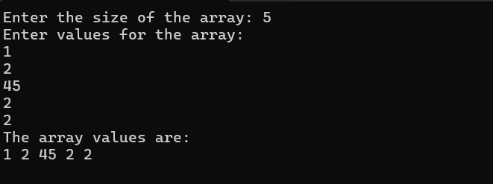

**TASK 9:**

#include <iostream>

#include <string>

using namespace std;

struct Inventory {

int productID;

string name;

int quantity;

int price;

};

int main() {

int n;

cout << "Enter the number of products: ";

cin >> n;

Inventory *product = new Inventory[n];

for (int i = 0; i < n; i++) {

cout << "\nEnter details for Product " << i + 1 << ":" << endl;

cout << "Product ID: ";

cin >> product[i].productID;

cout << "Product Name: ";

cin >> product[i].name;

cout << "Quantity: ";

cin >> product[i].quantity;

cout << "Price: ";

cin >> product[i].price;

}

int totalValue = 0;

for (int i = 0; i < n; i++) {

totalValue += product[i].quantity * product[i].price;

}

cout << "\nTotal inventory value: " << totalValue << endl;

delete[] product;

return 0;

}

**OUTPUT**:

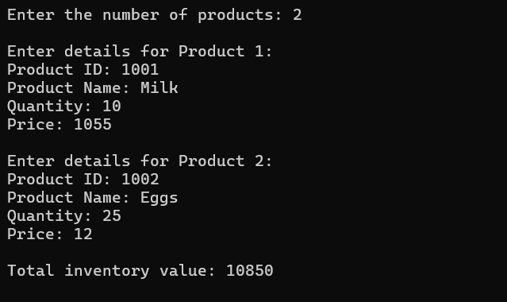

**TASK 10:**

#include <iostream>

using namespace std;

int main() {

int x, y, z;

cout << "Enter dimensions of the 3D array (x, y, z): ";

cin >> x >> y >> z;

int*** array = new int**[x];

for (int i = 0; i < x; i++) {

array[i] = new int*[y];

for (int j = 0; j < y; j++) {

array[i][j] = new int[z];

}

}

for (int i = 0; i < x; i++) {

for (int j = 0; j < y; j++) {

for (int k = 0; k < z; k++) {

cout << "Enter value for array[" << i << "][" << j << "][" << k << "]: ";

cin >> array[i][j][k];

}

}

}

cout << "3D Array Values:" << endl;

for (int i = 0; i < x; i++) {

for (int j = 0; j < y; j++) {

for (int k = 0; k < z; k++) {

cout << array[i][j][k] << " ";

}

cout << endl;

}

cout << endl;

}

for (int i = 0; i < x; i++) {

for (int j = 0; j < y; j++) {

delete[] array[i][j];

}

delete[] array[i];

}

delete[] array;

return 0;

}

**OUTPUT:**

